Improving access to Structured Workplace Learning Opportunities
In 2016 the state government funded a reformed Structured Workplace Learning program with the 31 Local Learning and Employment Networks across Victoria. The LLENs now facilitate access to appropriate workplace learning opportunities for senior vocational students via an online portal. The new SWL State-wide Portal supports the role of the LLENs to engage with local industry and business to prepare students for successful post-school transitions. Schools will be able to source opportunities for difficult to place students.
Go to: www.workplacements.education.vic.gov.au OR Google SWL HOME
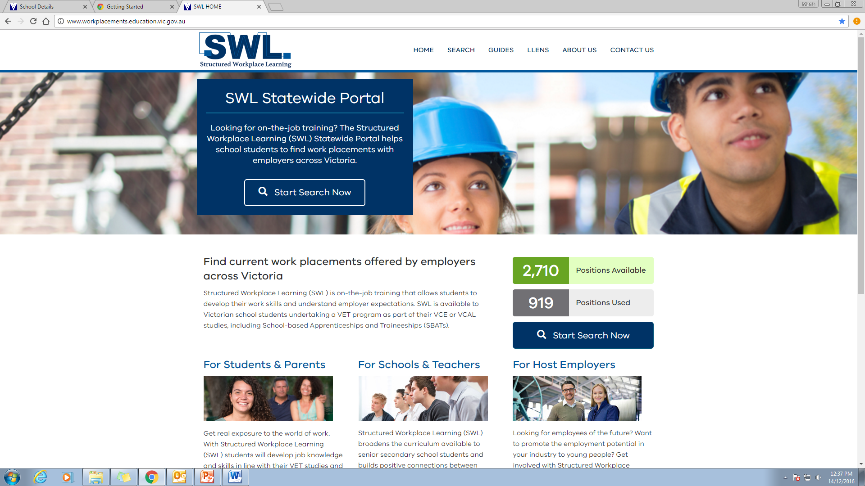
Screen shot taken 14/12/16

This is a FREE service to Schools. Anyone can view the range of opportunities available across Victoria. You can search by VET Course, industry or suburb.
Students searching for SWL click Share this opportunity with your teacher once they have found a placement they wish to apply for.
The designated SWL representative at the school discusses the placement with the student, confirms dates with the employer, changes opportunity status on the website and prints the relevant paperwork from the website.
The student arranges the meeting with the employer, (completes interview if required) and gets paperwork signed.
For more information about the portal contact:
maria.cox@bmllen.com.au (Mon – Fri: P: 9361 9323 M: 0439 383 016) or dianne.debrincat@bmllen.com.au (Tues & Thurs: P: 9361 9325.

