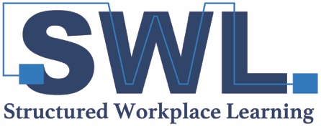
SCHOOL PORTAL USER ACCESS REQUEST FORM
Please complete, scan and email to maria.cox@bmllen.com.au or Dianne.debrincat@bmllen.com.au
REQUESTOR INFORMATION
School
Requestor Name
Requestor Email
Requestor Phone Number

ACCESS REQUEST TYPE ADD / REMOVE (Please circle one)

USER (TEACHER) INFORMATION
User’s Work Email
First Name
Last Name
Position Title
School Phone
School Mobile
Include user in Mailing List
Include user in Opportunity Sharing workflow

USER TRAINED BY (FOR ADD REQUESTS ONLY) Note: It is a requirement that all new users
receive user training from their LLEN prior to the granting of access to the SWL portal
Trainer Name
LLEN
Date Trained

Note: For non –government schools, a School Participation Agreement must be in place for your school to be granted access to the SWL portal.

