nEW wEBSITE

IMPROVING WORKPLACE LEARNING FOR STUDENTS
  - INTRODUCING THE SWL STATE-WIDE PORTAL
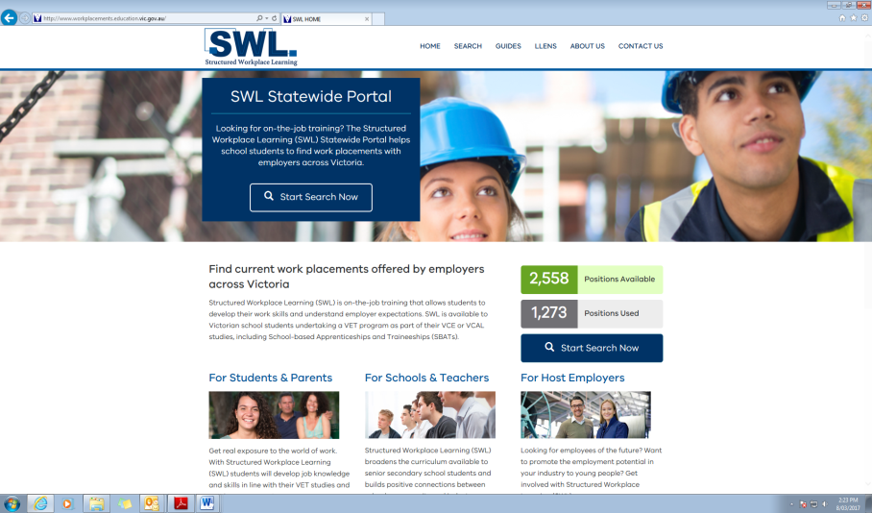
The Victorian State Government has introduced a new website to support Structured Workplace Learning (SWL).
Across Victoria, senior secondary students can now access quality employers who offer valuable workplace learning opportunities which match their vocational studies (VET) on-line using the new SWL State-wide Portal.
www.workplacements.education.vic.gov.au

highlighting quality employers
The SWL portal provides a professional outlook on the SWL opportunities that are available across the state. Students searching for a quality employer will be able to share details of the opportunity with their teacher. The school will be able to see if the opportunity is suitable for the student – and employers don’t receive calls that are asking for things they don’t offer. As placements are arranged the opportunity disappears until such time as the employer wishes to offer another.
Workplace Learning Coordinators work with local businesses to ensure that a good match is possible between the SWL opportunity and the student. A Workplace Learning Coordinator listens to what employers are able to offer and places it on the SWL State-wide Portal.
Brimbank and Melton schools have a strong and dynamic focus on vocational learning. The VET programs which are delivered in schools prepare students for occupations that have strong employment prospects in Melbourne’s West. They also need local workplaces that can further develop their skills and knowledge.
Go to: www.workplacements.education.vic.gov.au to see the SWL opportunities businesses like yours are already offering.

Be among the first in your local area to show you are a quality employer.
For more information contact the Workplace Learning Coordinator in your area: maria.cox@bmllen.com.au

